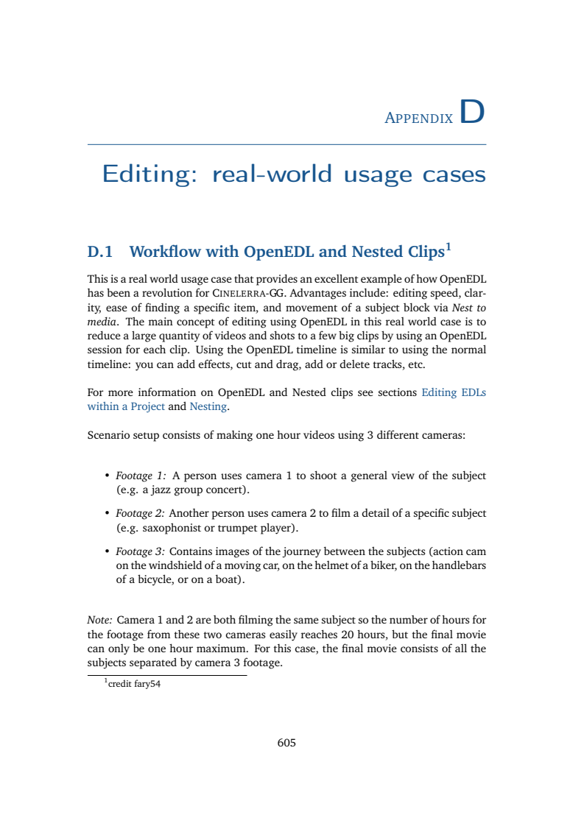
Scenario setup consists of making one hour videos using 3 different cameras:

• Footage 1: A person uses camera 1 to shoot a general view of the subject
- a) Barcelona (e.g. a jazz group concert)
- b) Lisbon (e.g. spanish concert)
• Footage 2: Another person uses camera 2 to film a detail of a specific subject
- a) Barcelona (e.g. saxophonist or trumpet player)
- b) Lisbon (e.g. guitarist or double bassist)
• Footage 3: Contains images of the journey between the subjects (action cam
on the windshield of a moving car, on the helmet of a biker, on the handlebars
of a bicycle, or on a boat).

